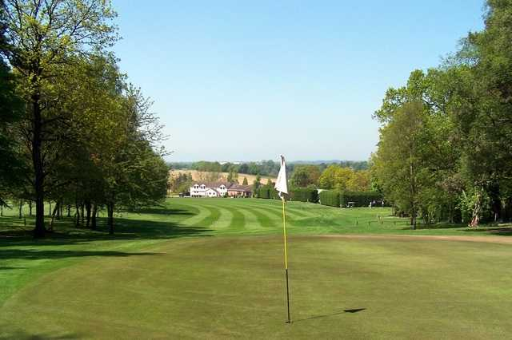**Supported by WBA Former Players Association**

Breakfast at 11am - Tee Off at Noon

Market Drayton Golf Club

Sunday 2nd September 2018

Remembering a Legend

Members £45.00 Guests £47.50

Full Breakfast 1st, 2nd & 3rd

With 18 holes of Golf Individual and

2 Course Presentation Team Award

Dinner Course comps

Donations welcomed at all events throughout 2018

|  |  |  |
| --- | --- | --- |
| Title |  | Details |
| 1st Name |  | |
| 2nd Name |  | |
| House Number/Name |  | |
| Road, Street, Etc |  | |
| Place |  | |
| Post Code |  | |
| Payment | £45.00/£47.50 | |

Please cross out the inappropriate amount.

**WBA SUPPORTERS GOLF SOCIETY  BANK DETAILS**

**BANK:**     HSBC   114 High Street, Stourbridge DY8 1DZ

**SORT CODE:**  40-43-17

**ACCOUNT No.**  72195763

**A/C NAME:** WBA SUPPORTERS GOLF SOCIETY

**BIC No.**  MIDLGB2111T

**Secretary/Treasurer**

Alan Jones-Bratt

30 Bigbury Lane

Stourport on Severn

Worcestershire

DY13 9JG

Mobile 07786 708362

aj-b@wbagolf.co.uk

Members £45.00

Guests £47.50